WILLIAMS OCTET REUNION WEEKEND 2017
DETAILS & SCHEDULE OF EVENTS

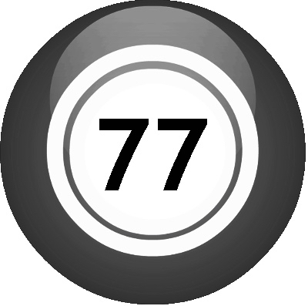
Greetings!

We’re so glad you can join us for the biennial gathering of Williams Octet alums and the people who love them! It’s been two years since our memorable 75th anniversary reunion, and we’re finally rested and ready to do it again. About 40 guys and 25 guests are planning to be with us this year and that alone is worth celebrating. So here’s to a weekend of reconnecting, rejuvenating, reune-ing, and basically singing ‘til we drop!

Below are some important details and a schedule for the weekend.

SHEET MUSIC & MP3s
We’re doing a handful of ensemble songs this year, so come prepared to sing:
- Come Fill Your Glasses Up
- Love the One You’re With
- Find Another You
- Please
- No Diggity
- Parting Blessing
- And the “new college song,” Echo of Williams

Sheet music and MP3s (where available) can be found in the 2017 OCTET REUNION dropbox at https://www.dropbox.com/sh/cu328vczxnvpynn/AACloqiWJ6WtvzMac0RklKCMa?dl=0
Hard copies of the sheet music will be available at rehearsal.

BINDERS
Please bring a small black binder to hold your music – WE DON’T HAVE ANY EXTRAS!
Bring pencils, too.

DRESS CODE
We’re going with the classic Octet Alumni outfit – blue blazer, grey pants, white shirt, Williams tie, black shoes.

COST OF WEEKEND
Thanks to contribution from the college and several alums, we only need you to kick in $30 per adult (kids are free) to cover food, bartender at afterglow, tailgate, choral risers, recording etc.
Please give cash or check to Chris Winters ‘95 (checks payable to Williams College.)
Meanwhile, we're continuing to raise money for the Warren G. Hunke Charitable Trust which will fund our reunions in the future. You’ll hear more about that at reunion.

SCHEDULE

FRIDAY, NOVEMBER 10

1:30 – 3:30 -- EARLY "ERA" REHEARSALS
Location: TO BE DETERMINED BY EACH GROUP.

4:00 – 7:00 -- ENSEMBLE REHEARSAL – FOR EVERYONE
Location: Presser Choral Room in the Bernhard Music Center

7pm -- FRIDAY FOOD AND DRINKS – An informal hang with eats and drink provided Location tbd

--------------------------------------------------------------------------------------
SATURDAY, NOVEMBER 11

9:30 – 11:30am -- FINAL ENSEMBLE REHEARSAL – FOR EVERYONE
Location: Presser Choral Room
Mandatory. Last chance to work on ensemble numbers.

11:30 on -- TAILGATE - before and during the football game.

NOON -- GAME – WILLIAMS VS. AMHERST

SATURDAY AFTERNOON – ERA REHEARSALS (as needed)

DINNER – There is no formal dinner at the Inn this year. Instead, we’re starting the concert early-ish at 7pm and having food and drink at the Afterglow. If you need sustenance to make it through the concert, you’re on your own. Eat something now!

6:15 SHARP!!! – assemble in Presser choral hall for final warm-up

7:00 – WILLIAMS OCTET 77th ANNIVERSARY CONCERT – Brooks Rogers

9:00 -- AFTERGLOW AND CABARET** – At the Alumni House, lower floor
With food, drink, more singing, more bonding.

**If you have something for the Cabaret, please contact Scott Todd ’86 (scott@scottsasha.com).

--------------------------------------------------------------------------------------
SUNDAY, NOVEMBER 12

11:00 -- BRUNCH
Location: Driscoll Dining Hall
This is a casual hang for any who stick around for last goodbyes and a chance to eat campus food. Go through the line (pay cash at door) and then bring your tray to upstairs meeting room.

